

**FACULTY OF COMPUTING**

**SECD2613**

**SYSTEM ANALYSIS & DESIGN**

**SECTION 02, 2023/2024**

**TOPIC:**

**PROJECT PLANNING PHASE 1**

**LECTURER’S NAME: DR. MUHAMMAD ALIFF BIN AHMAD**

|  |  |  |
| --- | --- | --- |
| **BIL** | **GROUP MEMBERS** | **MATRIX NO** |
| 1 | MUHAMMAD ZAYYAD BIN BADRUL HISHAM | A23CS3015 |
| 2 | MUHAMMAD SHAHRUL IMAN BIN KAMAL | A23CS3013 |
| 3 | MUHAMMAD AZFAR BIN SHARIFUDDIN | A23CS0123 |
| 4 | AMR YOUSEF HAZAEA ALWAFI | A23CS4005 |

1. Introduction 2

2. Background Study 3

3. Problem Statement 4

4. Proposed Solutions 5

4.1. Solutions 6

4.2. Technical Feasibility Studies 6

4.2.1. Software Requirements 7

4.2.2. Hardware Requirements 7

4.3. Operational Feasibility Studies 8

4.4. Economic Feasibility Studies 10

5. Objectives 12

6. Scope of the Project 13

7. Project Planning 15

7.1. Human Resources 16

7.2. Work Breakdown Structures (WBS) 16

7.3. PERT Chart 19

7.4. Gantt Chart 19

8. Benefit and Overall Summary of Proposed System 20

8.1. Simplified the supervisor searching process 21

8.2. Facilitate the supervisor task 21

8.3. Accessible and convenient 21

8.4. Savings Time 22

9. References 22

### **Introduction**

The Postgraduate Supervision Module is a project under UTM crew that is proposed to create a platform that could provide postgraduate candidates with an easier way to find their potential supervisor and interact with them indirectly. It also allows the students and supervisors to seamlessly work together on one platform. Some of its features allow the supervisor to check the student thesis progress, enable students to see their supervisor schedule and appoint a meeting with them.

The project will be launched on a website that should be accessible to everyone and open for every postgraduate candidate who is trying to find a supervisor for their studies. The project is proposed to eliminate the usual problem of manual method that postgraduate candidates need to experience to find their potential supervisor. Which by providing a dedicated platform and simplifying the process of searching and working with supervisor. For example, instead of searching through contacts and trying to figure out how to reach them, candidates can simply use the website to find anyone who could assist them.

By having this platform, it ensures that candidates can find their supervisor easily and connect with them more seamlessly. Therefore, making the process of furthering postgraduate studies becomes less complex and straightforward.

### **Background Study**

The Postgraduate Supervision Module is done to help postgraduate candidates to find their supervisor easier, which is the opposite of the normal method, where postgraduate candidate is required to find their supervisor through contacts, social media, meet and many more. Because of that, to ensure the process of furthering postgraduate studies becomes easier for most of the students in Malaysia, it is decided that The Postgraduate Module to be proposed which allows candidates to find their supervisor by just visiting a website. Other than that, the projects also aim to help and further ease the communication and work between postgraduate's candidate and their supervisor by providing multiple features such as check and track progress, scheduling, appointments booking and many others. The projects will be developed using PHP Laravel framework, a MVC controller framework that is usually used to serve the website and API, it is also will be developed withing 6 months period to ensure it can be used as fast as possible for students convenient. In summary, the Postgraduate Supervision module will be developed to help students find and work with their supervisors seamlessly while ensure that the process of furthering postgraduate studies for students in Malaysia is easier and effortless.

### **Problem Statement**

For the proposed project, the main concern or problem mostly came due to the inconvenience or some burden that some postgraduate candidates need to handle, which is to find their supervisor for their postgraduate studies. Unfortunately, in Malaysia, there is no platform available that could help postgraduate candidates to find and contacts with their potential supervisors easily and seamlessly. The student in most cases is required to search for their supervisor manually, for example, most of the time students are required to search for their potential supervisor from their social media, contacts or even need to rely on referrals from some other people. This problem could lead to demotivation, unnecessary inconvenience for potential candidates and time consuming. Hence, the module is proposed to help reduce or eliminate the problem for most of the candidates and ensure the process of furthering postgraduate studies becomes seamless. The proposed module should help candidates to find their supervisor by listing all the lecturers or individuals that are available for the supervision, the platform should display their contacts and description so that they students can decide whether the individual is suitable to be their supervisor. Hence, for the summary, this problem seems to be important to be taken care of, as the by providing a platform for students to be able to connect with their supervisor, it ensures that their postgraduate journey to be smooth and away from unnecessary or impractical problems, which ultimately, allows them to focus on what it is important, which is their studies and research.

### **Proposed Solutions**

#### **Solutions**

Based on the observations and further investigation on the problem, it cannot be denied that the best solutions are to develop and prepare a website application for postgraduate candidates to find their supervisor seamlessly. In order to further improve the postgraduate student experience, the platform should offer several features that could help them even during their studies. Aside from the essential features which is too able to look up all the available supervisor that ready to supervise postgraduate students, the platform should also display the time and schedule for each of the supervisor that listed their name on the platform. Aside from that, the platform should also be a feature for students to be able to arrange and schedule their meetings with their chosen supervisor based on their supervisor’s schedule. The platform will also provide a feature where students can upload their documents and thesis to be checked and verified, which allows their supervisors to evaluate their progress relatively easily. Therefore, to summarize, these proposed solutions could help solve the main problem and increase the usability and reliability of the system, which ensures it is well helpful among students.

#### **Technical Feasibility Studies**

Based on the solution given, several feasibility studies will be conducted, one of the main feasibility studies that will be assessed is the technical feasibility. For these studies, the requirements and resources will be evaluated whether the tools and resources to build the proposed platform are available and exist as well as if it is enough to solve the problem and achieve solutions.

##### ***Software Requirements***

Based on figure 4.0, these are some of the software that would be used to develop the proposed projects.

|  |  |  |  |  |
| --- | --- | --- | --- | --- |
| **Software** | **Operating System** | **Processor** | **Memory (RAM)** | **Storage** |
| *Laravel 11.x (PHP Framework)* | Linux, macOS, Windows | N/A | N/A | N/A |
| *Chrome*  *(Google,2024)* | Windows 7 or later, macOS X 10.10 or later, Android 5.0 or later | Intel x86-64 compatible processor (or ARM for Android) | Minimum 1 GB (more recommended for multiple tabs) | Varies depending on usage and extensions |
| *Amazon Web Hosting Service* | N/A | N/A | Varies depending on plan | Varies depending on plan |
| *Amazon Database Hosting* | N/A | N/A | Varies depending on plan | Varies depending on storage type and database size |
| *Visual Studio Code*  *(Microsoft, 2021)* | Windows 7 or later, macOS X 10.10 or later, Linux | 1.5 GHz or faster processor | Minimum 1.5 GB | 1 GB of free disk space |

***(Figure 4.2.0)***

##### ***Hardware Requirements***

Based on the software requirements above, the development machine must fulfil these several requirements to be able to develop the proposed projects. Figure 4.1 shows the minimum requirements required to use the software above and develop the proposed projects.

|  |  |  |
| --- | --- | --- |
| **Component** | **Development Machine** | **Server (AWS)** |
| *Operating System* | Windows 10/macOS/Linux | N/A |
| *Processor* | Multi-core (e.g., Intel Core i5) | Varies depending on AWS plan |
| *Memory (RAM)* | 8GB minimum, 16GB+ recommended | Varies depending on AWS plan |
| *Storage* | 256GB SSD minimum | Varies depending on AWS plan and database size |

***Figure (4.2.1)***

#### **Operational Feasibility Studies**

For the proposed module, it is also important to assess the operational feasibility of the module, in order to gain understanding of whether the project can solve the given problem statement and be able to take opportunity into some of the others things. Figure 4.2 shows some of the problems that the proposed solution can solve.

|  |  |
| --- | --- |
| **Problem** | **Solution** |
| **Manual Search for Supervisors:** Postgraduate candidates in Malaysia have an underlying issue of always needed to conduct a manual search for finding supervisor. This involves scouring social media, personal contacts, and relying on referrals, leading to inefficiency and time-consuming efforts. | Develop an web application that listing of available supervisors available to supervise the students and provide detailed profiles for each supervisor, including contact information, academic background, research interests, and availability for supervision. |
| **Lack of Dedicated Platform**: Since there is a little to no dedicated platform available that could help students find their supervisor, it cannot be denied that this could cause a slight burden on candidates that try to further their postgraduate studies. Hence give to the increasing in the likelihood of demotivation and inconvenience. | Development of a dedicated platform for postgraduate candidate students that are looking to search for supervisor's candidate. By having this dedicated platform, it is easier for students to search for suitable supervisor and thus making the experience of furthering postgraduate studies become more pleasantly |
| **Time Consumption**: The manual search process consumes a significant amount of time that could otherwise be allocated to something more significant. Due to that, candidates spend considerable effort sifting through many ways to search for supervisors, detracting them from things that are more beneficial and important. | Offers an accessible and 24-hour web application for students who are trying to seek supervisor for their postgraduate studies. As well as, providing features such as thesis monitoring, appointments schedule and many more to further facilitate and make the communication process easier. |

***(Figure 4.3.0)***

#### **Economic Feasibility Studies**

For the economic feasibility studies, the figures listed below are estimated cost, benefits and assumptions. In figure 4.4.3 and 4.4.4, it showed the Cost-Benefits-Analysis (CBA), both of which lead to the value of profitability index 2.9, which means it is profitable and economically feasible.

* + 1. **Estimated Cost & Benefits**

|  |  |
| --- | --- |
| Estimated Cost | |
| Hardware | RM 10,000 |
| One-Time payment for staff | RM 30,000 |
| Hosting | RM 2,000 per year |
| Maintenance | RM 2,500 per year |

**(Figure 4.4.0)**

|  |  |
| --- | --- |
| Assumptions | |
| Discount Rate | 10% |
| Sensitivity Factor | 1.1 |
| Sensitivity  Benefits | 1 |
| Annual Changes in production cost | 5% |
| Annual Changes in benefits | 4% |

**Figure (4.4.1)**

|  |  |
| --- | --- |
| Benefits | |
| Time Savings | RM 500 per month |
| Enhance Productivity | RM 1000 per week |
| Accessibility & Convenient | RM 1200 per month |

**(Figure 4.4.2)**

* + 1. **Cost-Benefit-Analysis (CBA)**

|  |  |  |  |  |
| --- | --- | --- | --- | --- |
| Cost | Year 0 | Year 1 | Year 2 | Year 3 |
| Development Costs:  Hardware  One-Time Payment Staff | RM 11,000  RM 33,000 |  |  |  |
| Total | RM 44,000 |  |  |  |
| Production Cost:  Hosting  Maintenance |  | RM 2200  RM 2750 | RM 2310  RM 2888 | RM 2541  RM 3177 |
| Annual Prod. Costs  (Present Value) |  | RM 4950  RM 4500 | RM 5198  RM 4725 | RM 5718  RM 5198 |
| Accumulated Cost |  | RM 48,500 | RM 53,225 | RM 58,423 |

**(Figure 4.4.3)**

|  |  |  |  |
| --- | --- | --- | --- |
| Benefits | Year 1 | Year 2 | Year 3 |
| Time Savings | RM 6000 | RM 6240 | RM 6490 |
| Enhance Productivity | RM 52,000 | RM 54080 | RM 56243 |
| Accessibility & Convenient | RM 14,400 | RM 14,976 | RM 15,575 |
| Annual Ben  (Present Value) | RM 72,400  RM 65,818 | RM 75,296  RM 62,228 | RM 78,308  RM 58,833 |
| Accumulated Benefits | RM 65,818 | RM 128,046 | RM 186,879 |
| Gains Or Loss | RM 17,318 | RM 74,821 | RM 128,456 |
| Profitability Index | (128456/44000) = **2.9** | | |

**(Figure 4.4.4)**

### **Objectives**

For the proposed module, there are several objectives or criteria that the project needs to be fulfilled, most importantly how can it solve the given problem and achieve intended result. One of the proposed module's main objectives is to reduce the human effort in which making the task to find supervisor for postgraduate candidate easier and seamless. The module that will be developed should serve as a platform that gathers all supervisors so that it could serve as the main tool for students to search for potential supervisors for them to further their postgraduate studies. This clearly could help and solve the main concern, which is the trivial and manual task that postgraduates need to do to find their supervisor for furthering their postgraduate studies. Aside from that, this proposed module also aims to help students and supervisors to work together effectively and efficiently, by providing several features that could help them work together such as appointment scheduling, schedule of supervisor, thesis, and research monitoring features. Overall, this module aims to reduce postgraduate candidates’ task to find their potential supervisor and to serve as a platform that could help make the journey of furthering postgraduate education better and bearable.

### **Scope of the Project**

For the proposed module, there are several aspects as well as some limitations that can be extracted and described specifically. In the functionality aspect, the proposed module should fulfill its main purpose, which is to serve as a platform that lists all the individuals that are qualified to be supervisor for potential postgraduate students, for the supervisor, they are given an option to check the students background and decide whether to accept the student request to be their supervisor. Aside from that, the proposed module offers several other features that serve to facilitate students and supervisor experience in working together, making it more effective and efficient. For example, the platform offers thesis monitoring features that allow students to upload their thesis to be evaluated by supervisor, this also helps supervisors to evaluate the students' progress and give appropriate remarks on the go. The module also offers an appointment schedule for students in case they want to arrange meetings with their supervisor one-on-one, which automatically updates and schedules the meetings in both of supervisor and students’ calendar. Additionally, to delve deeper into the supervisor role, the project upon been developed will initially ask the supervisor for credentials information, such as name, affiliation, background, and field of expertise as well as google scholar identification. As for the supervisors that have been registered, they also would be able to check the number of students they have supervised, check for the students' background when they requested to be supervised, as well as be able to conduct an interview before deciding to supervise some the students.

Although there are many aspects that the module will cover, there are also some of the limitations that can be well seen. Firstly, the modules are only available within the domain of the website application and not in the form of mobile or desktop applications, then there is still no consideration whether the module will be expanded into desktop or mobile application in the future. Secondly, it has only been developed to be dedicated to the students who will be furthering postgraduate studies and not for the other students that are on different levels. Also, the module will not provide the feature that allows direct chat between students and their supervisor due to reducing the development and maintenance cost. Thirdly, the module although being developed to help for postgraduate student find their supervisor, it only caters, and build dedicated to mainly students in Malaysia and within the domain of Malaysia university. Hence, there is no intention to cover and provide the service to all of the postgraduate candidates outside of Malaysia. Lastly, the platform also not to be responsible to gather and prepare the list of available supervisors that will be register on the website, which means that all the supervisors available are the individual who is consented to be on the platform and ready to supervise potential students. Therefore, these are some of the things that the project will be covering as well as some of the things that are outside of the project scope due to several dedicated reasons and limitations.

### **Project Planning**

#### **Human Resources**

Regarding human resources, there are several roles given to the team members as well as their task at each phase.

1. *Setup Phase:*
   * Project Manager
2. *Research and Requirements:*
   * Researcher/Analyst
3. *Design and Development*
   * UI/UX Designer
   * Full Stack Developer:
4. *Testing and Deployment:*
   * QA Tester
   * System Administrator
5. *Maintenance and Support:*
   * Technical Support Specialist

|  |  |
| --- | --- |
| Name | Role Performed |
| MUHAMMAD ZAYYAD BIN BADRUL HISHAM | Project Manager, Researcher/Analyst, System Administrator |
| MUHAMMAD SHAHRUL IMAN BIN KAMAL | UIUX Designer, Full Stack Developer |
| MUHAMMAD AZFAR BIN SHARIFUDDIN | Full Stack Developer, QA Tester |
| AMR YOUSEF HAZAEA ALWAFI | Full Stack developer, Technical Support Specialist |

**(Figure 7.0)**

#### **Work Breakdown Structures (WBS)**

1. **Setup Phase:**
   1. Define project goals and timeline.
   2. Establish project repository.
2. **Research and Requirements:**
   1. Research about the current manual methods.
   2. Gather stakeholder requirements.
   3. Define user stories and use cases.
3. **Design and Development:**
   1. Design UI mockups and wireframes.
   2. Develop supervisor and student profiles.
   3. Implement supervisor search and listing.
   4. Integrate thesis monitoring and appointment scheduling.
   5. Create extra functionality for supervisor-student interaction
4. **Testing and Deployment:**
   1. Conduct unit and integration testing.
   2. Fix bugs and issues.
   3. Deploy platform to hosting environment.
   4. Perform final testing and launch.
5. **Maintenance and Support:**
   1. Monitor platform performance.
   2. Address user feedback and issues.
   3. Update platform with new features or improvements.

|  |  |  |
| --- | --- | --- |
| **Task** | **Prerequisite Tasks** | **Estimated Time** |
| A. Define Project Goals and Timeline | - | 1 day |
| B. Establish project repository | - | 2 days |
| C. Research about the current manual methods | A, B | 3 days |
| D. Gather stakeholder requirements | C | 2 days |
| E. Define user stories and use cases | D | 2 days |
| F. Design UI mockups and wireframes | E | 5 days |
| G. Develop supervisor and student profiles | F | 7 days |
| H. Implement supervisor search and listing | G, F | 6 days |
| I. Integrate thesis monitoring | H | 6 days |
| J. Create extra functionality for supervisor-student interaction | I | 5 days |
| K. Conduct unit and integration testing | G, H, I, J | 4 days |
| L. Fix bugs and issues | K | 3 days |
| M. Deploy platform to hosting environment | L | 2 days |
| N. Perform final testing and launch | L | 1 day |
| O. Monitor platform performance | N | 3 days |
| P. Address user feedback and issues | N | 4 days |
| Q. Update platform with new features or improvements | P | 5 days |

**(Figure 7.2.0)**

#### **PERT Chart**

Figure 7.3.0 below is the pert chart based on the WBS, with the critical path of A-B-C-D-E-F-G-H-I-J-K-L-N-P-Q.

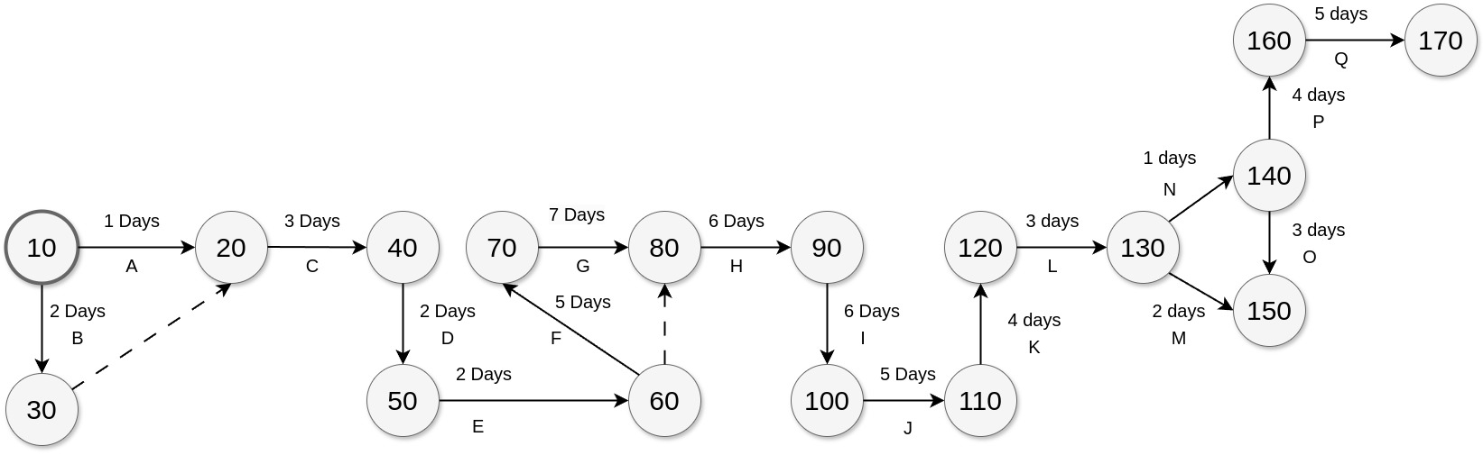

**(Figure 7.3.0)**

#### **Gantt Chart**

Figure 7.4.0 below shows the schedule in the form of pert chart, excluding the weekend.

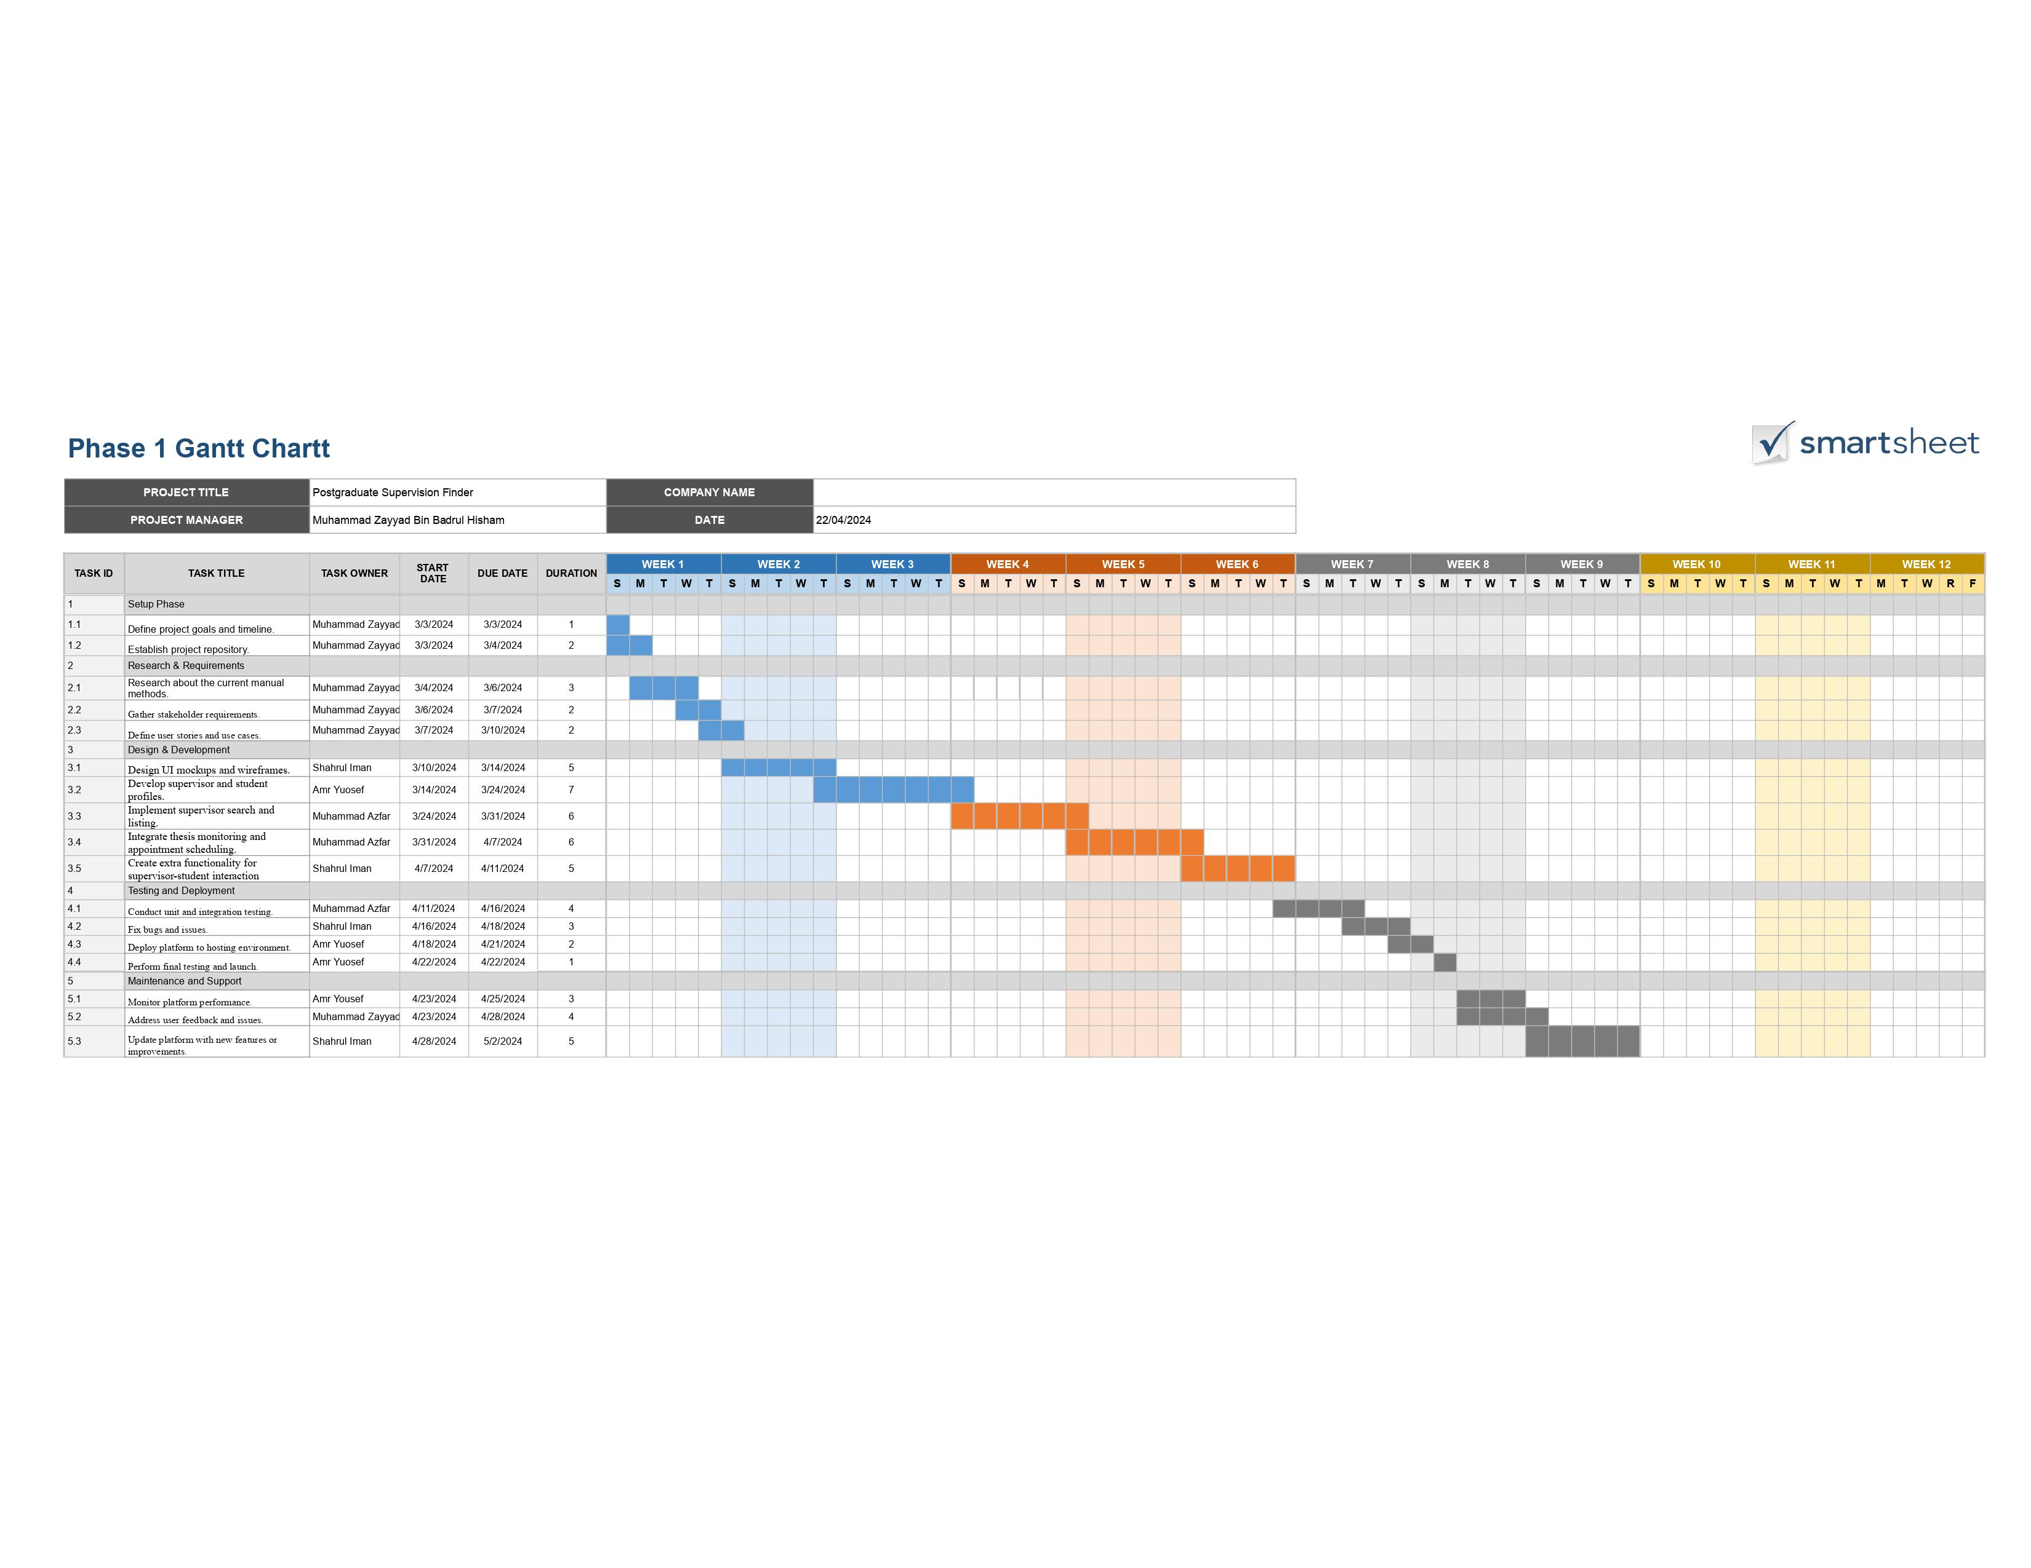

**(Figure 7.4.0)**

### **Benefit and Overall Summary of Proposed System**

#### **Simplified the supervisor searching process**

By developing a dedicated platform for supervisor searching, it streamlines the process of finding a suitable supervisor. With the supervision module, Potential students can easily browse through available supervisors based on their qualifications and expertise, reducing the time spent on manually searching and increasing the likelihood of finding a right and compatible supervisor. Additionally, aside from helping the potential postgraduate candidate, this module also helps supervisors effectively by providing a student's background profile to be reviewed. Thus. Helped supervisors to make informed decisions about accepting supervisory roles, leading to a smoother onboarding process.

#### **Facilitate the supervisor task**

Another benefit of this supervision module is that it provides multiple tools and features that assist supervisors in managing and working with their students effectively. For example, supervisors can access student profiles, track progress, and provide feedback within the system about students' work, which streamlines the communication and collaboration between students and supervisors. Which ultimately, allowing them to focus more on mentorship and guidance, ultimately enhancing the quality of supervision.

#### **Accessible and convenient**

Aside from the previous benefits, the system offers accessibility and convenience to both students and supervisors by providing a centralized platform that allows them to collaborate and work together effectively, for example, the supervision module is accessible everywhere as long as the individual are equipped with an internet connection. Additionally, this also means that users can access the system from various devices, such as computers, tablets, or smartphones, making it convenient for them to engage with the platform according to their preferences and schedules.

#### **Savings Time**

By reducing the work of the potential postgraduate students and facilitate some of the supervisors' tasks, such as providing students with an option to upload document and supervisors to monitor and review students work, the system saves time for both students and supervisors. From the student's perspective, the platform can quickly help them search for compatible supervisors, schedule appointments, and submit work, while supervisors can efficiently review student progress and provide feedback on their work. As a result of these benefits, both students and supervisor can enjoy the productivity increases and focus more on meaningful academic and professional activities, thereby enhancing efficiency.

In summary, the supervision module is proposed to help solve problems that came from the difficulty of finding supervisors for postgraduate candidates. With the module being developed, it hopes that it could fulfill all the candidates' needs and facilitate communication between students and supervisors by providing essential and multiple features that could achieve the desired expectation.

### **References**

Google. (2024). *Chrome browser system requirements - chrome enterprise and education help*. Google. https://support.google.com/chrome/a/answer/7100626?hl=en

Microsoft. (2021, November 3). *Requirements for visual studio code*. RSS. https://code.visualstudio.com/docs/supporting/requirements